|  |  |  |
| --- | --- | --- |
|  | **CHAROTAR UNIVERSITY OF SCIENCE & TECHNOLOGY**  **DEVANG PATEL INSTITUTE OF ADVANCE TECHNOLOGY AND RESEARCH** | D:\Admin\coursefile\Depstar-final-logo (1).jpg |

# Weekly Report

*In this report, students require to mention the work that has been done during the week and planning for the next week. (Please fill individual reports for each week)*

|  |  |
| --- | --- |
| **Student ID: 20DCS083** | **Student Name: Naitik Patel** |
| **From Date: 06/06/22** | **To Date: 10/06/22** |
| **Semester: 5th** | **Internship ID:** |

**Week-4**

**Domain: Web development**

**Technology: ReactJS**

**Work done last week (Attach supporting Documents):**

* **06/06/2022 (Monday)**

Learn why we need state management methods. We can manage the state using many methods some of them are using Context API, useContext hook, and Redux.

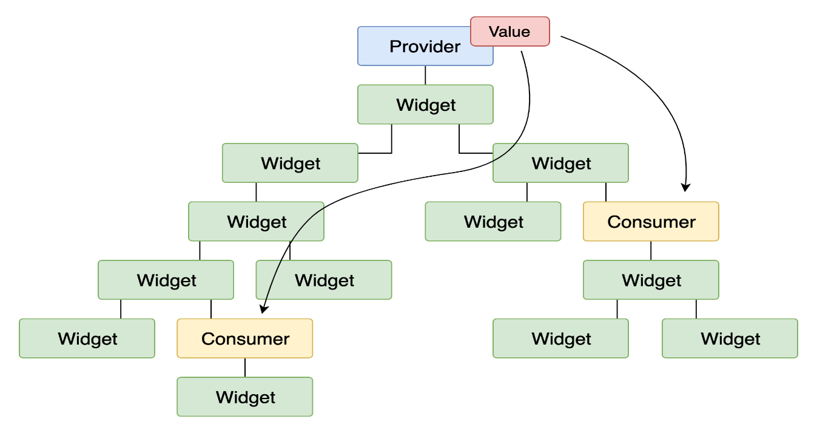

* **07/06/2022 (Tuesday) & 08/06/2022(Wednesday)**

Made a Restaurant UI Using ReactJs & Material UI. Also hosted on vercel.com

<https://restaurant-website-naitikp2002.vercel.app/>



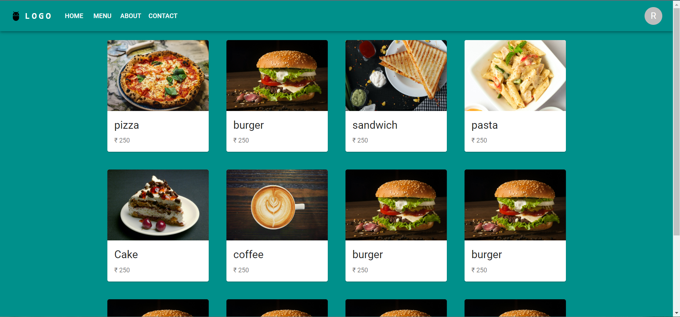



* **09/06/2022(Thursday)**

Started learning NodeJS and explored some basic modules like fs(file system), os(operating system), nodemon module.

Also, use npm chalk package to highlight data in the console.

* **10/06/2022 (Friday)**

**node CREATE** :  
 if the file does not exists – will be created.  
 if the file existed beforehand – a message it already existed will be presented.

**node INSERT** – this will append **.json** file with a new record at the very end of the top-level array JSON string.

**node REMOVE** – this will swap the recently appended record with an object of **null.**

**node DELETE** – this will completely remove (delete) file from the system (the directory).

**Plans for next week:**

Learn about HTTP and many Modules.

## References:

<https://vanillacamp.hashnode.dev/nodejs-fscrud/>

<https://reactjs.org/docs/hooks-state.html>



## Signature of External Guide Signature of Internal Guide